**LOLC Life Insurance Premium Collection Solution**

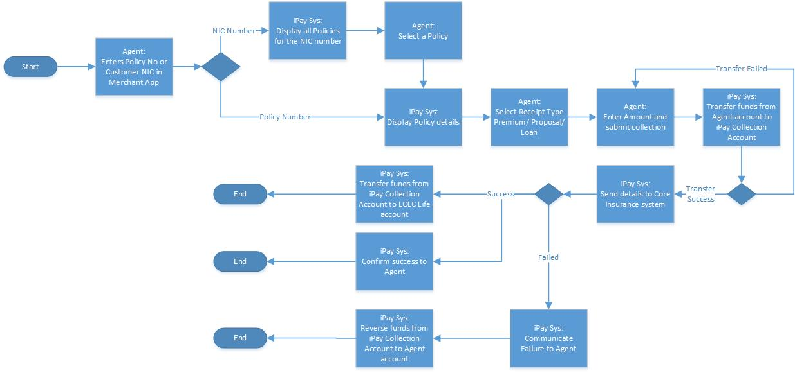

**User Stories**

Feature: Policy premium collection  
In order to facilitate the premium collection process of LOLC Life Insurance  
As a LOLC Life Ins Agent  
The user should be able to perform offline collections

Scenario: View Bank Account Balance  
Given the user is logged in as a LOLC Life Ins Agent  
When the user wants to view the balance of bank account approved by iPay  
Then the current balance should be displayed.

Scenario: Search Policy using policy number  
Given the user is logged in as a LOLC Life Ins Agent  
When the user enters a Policy Number  
Then a summarized view of the policy should be displayed.  
|Policy Number |Status |Outstanding Amount | Due Date |

Scenario: Search Policy using NID Number  
Given the user is logged in as a LOLC Life Ins Agent  
When the user enters a NID number  
Then a summarized view of all policies under the NID should be displayed.  
|Policy Number |Status | Outstanding Amount | Due Date |

Scenario: Select policy  
Given the user has entered a search parameter  
And Policy/ies are listed  
When the user selects a policy  
Then the Policy details should be displayed.  
|Policy No | Status | Name | NID No |Premium | Commencement Date | Issued Date | Deposit Balance | Outstanding Amount | Due Date | Frequency |

Scenario: Submit collection  
Given the user has selected a policy  
And user has entered the fields correctly  
| Receipt Type | Amount | Payee Mobile No |  
When the user submits the collection  
Then the internal fund transfer API should be initiated  
And Funds transferred from Agent bank account to iPay collection account.

Acceptance criteria

1. Amount cannot be Null. Error message “Please enter Amount”
2. Receipt Types – Premium, Proposal, Loan. If Receipt Type is not selected, error message “Please select Receipt Type.
3. Amount < Agent Bank Balance.
4. If Amount > Agent Bank Balance, error message “You have exceeded the permitted collection amount. Please deposit funds into your iPay approved bank account.”
5. If internal fund transfer failed, error message “Premium Collection Failed. Please try again” should be displayed and the user directed to the Submit Collection page.

Scenario: Successful transfer of funds to iPay Collection account  
Given the user has submitted a Premium Collection  
When the internal fund transfer is successful  
Then the Premium Collection update should be sent to the Core Insurance software.

Scenario: Successful notification to Core Insurance  
Given the user has submitted a Premium Collection  
And the funds have been successfully transferred to the iPay Collection Account  
When the Core Insurance has been updated successfully  
Then the funds should be transferred to the LOLC Life Ins account from the iPay Collection Account  
And the success should be communicated to the Agent in the app  
And the payee should be notified of payment success via SMS.

Scenario: Unsuccessful notification to Core Insurance  
Given the user has submitted a Premium Collection  
And the funds have been successfully transferred to the iPay Collection Account  
When the Core Insurance has **NOT** been updated successfully  
Then the failure should be communicated to the Agent in the app   
And funds should be reversed from the iPay Collection Account to the Agent Bank Account.